**Project Design Phase-II**

**GENERATIVE AI WITH IBM CLOUD**

|  |  |
| --- | --- |
| Date | 29 June 2025 |
| Team ID | LTVIP2025TMID34440 |
| Project Name | Generative AIwith IBM Cloud  EduTutor AI |
| Maximum Marks | 4 Marks |

**EDUTUTOR AI :**

EduTutor AI is an AI-powered personalized education platform that revolutionizes the way students learn and educators assess progress. It provides dynamic quiz generation, student evaluation, Google Classroom integration, and real-time feedback—all powered by IBM Watsonx and Granite foundation models. Designed with modular architecture, this platform streamlines personalized education and enhances learning outcomes for students across academic levels.

**Example:** [**(Simplified)**](https://developer.ibm.com/patterns/visualize-unstructured-text/)

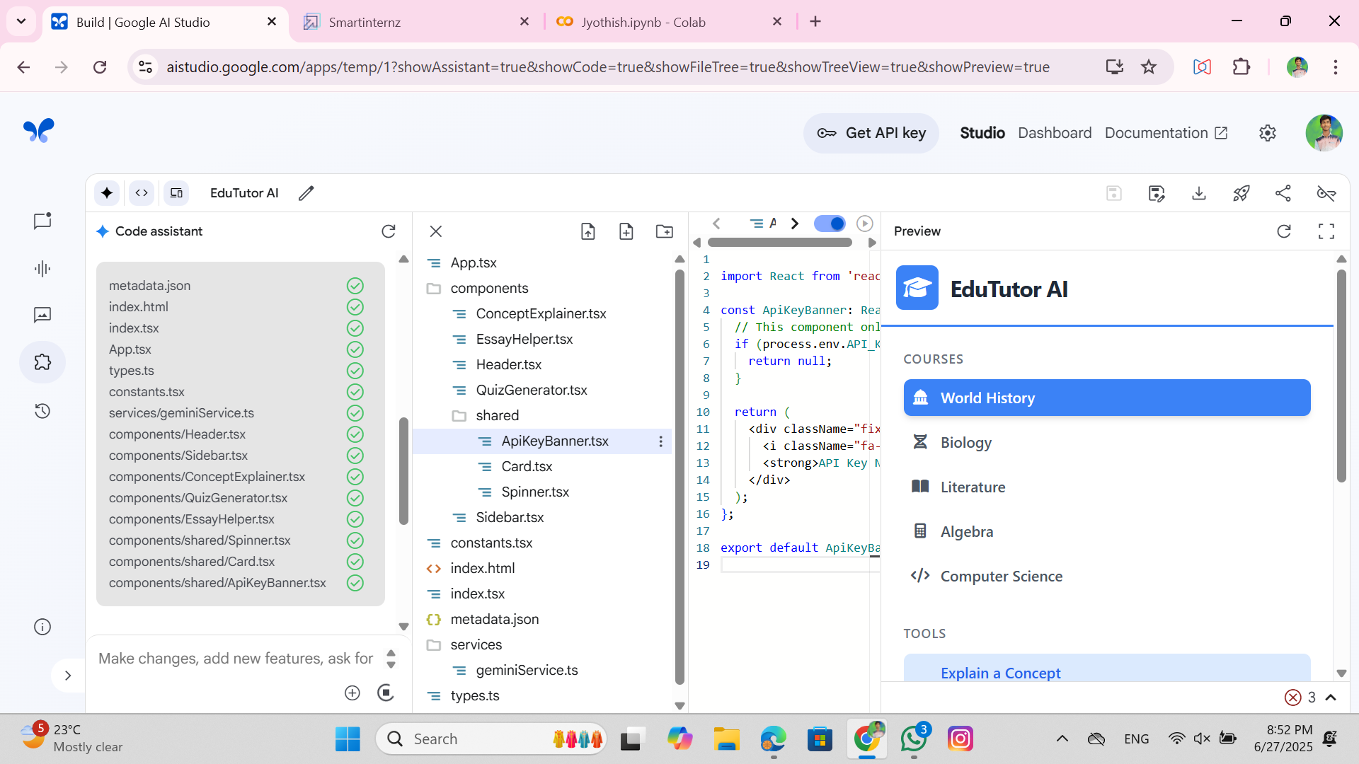

**User Stories**

Use the below template to list all the user stories for the product.

| **User Type** | **Functional Requirement (Epic)** | **User Story Number** | **User Story / Task** | **Acceptance criteria** | **Priority** | **Release** |
| --- | --- | --- | --- | --- | --- | --- |
| Customer (Mobile user) | Registration | USN-1 | As a user, I can register for the application by entering my email, password, and confirming my password. | I can access my account / dashboard | High | Sprint-1 |
|  |  | USN-2 | As a user, I will receive confirmation email once I have registered for the application | I can receive confirmation email & click confirm | High | Sprint-1 |
|  |  | USN-3 | As a user, I can register for the application through Facebook | I can register & access the dashboard with Facebook Login | Low | Sprint-2 |
|  |  | USN-4 | As a user, I can register for the application through Gmail |  | Medium | Sprint-1 |
|  | Login | USN-5 | As a user, I can log into the application by entering email & password |  | High | Sprint-1 |
|  | Dashboard |  |  |  |  |  |
| Customer (Web user) |  |  |  |  |  |  |
| Customer Care Executive |  |  |  |  |  |  |
| Administrator |  |  |  |  |  |  |
|  |  |  |  |  |  |  |
|  |  |  |  |  |  |  |
|  |  |  |  |  |  |  |